Making a Column Customer Specific
Option 1
Add the installed module to the column class. Per Mike, this is the more inclusive and, therefore, preferred method.
<[Module](Modules.LAPRA)>

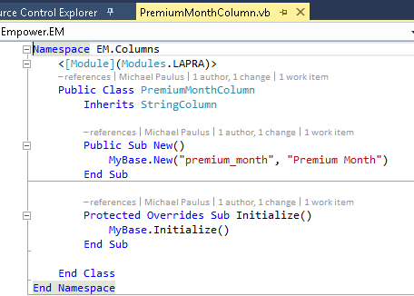

Option 2
When adding the column to the InitializeColumns sub-routine of an entity or document, set the column’s IsVisible property based on the installed module.
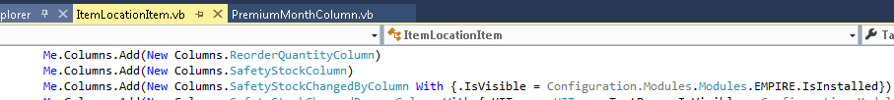

If you look at the IsVisible property on the Column class, you will see that the Set method raises an event (shown on the next page). So… if you want the event to be raised, then use Option 2.

From Column.vb
